Build Chess Game — LLD + Code — Complete Notes

Introduction
Building a chess.com clone — a full online chess platform with:
- Multiple simultaneous matches
- Score-based matchmaking
- Complete standard chess rules
- In-app chat (via Mediator pattern)
Prerequisites: Basic knowledge of how chess pieces move. Without that, the LLD will be hard to follow. You only need to know which piece moves how — that's enough.
Why it's valuable: Common LLD interview question AND a strong standalone portfolio project.

Functional Requirements
# | Requirement
1 | Multiple users can play chess simultaneously
2 | Each user has a score (default 1000)
3 | Score-based matchmaking — match users with the closest score difference (avoid beginner vs expert)
4 | Standard chess rules — must be extensible for custom rules later
5 | Users within a match can send/receive messages — in-app chat (Mediator pattern)
6 | User can quit mid-match — loser penalty, winner bonus; draw = no change
7 | Multiple matches stored in Map<matchId, Match> in the manager
8 | Users arrive → waiting lobby; new user matched with closest-score waiting user
Scoring rules (as stated):
- Quit → quitting player loses ~30 points; opponent gains ~50 points (code sample shows winner +30, loser -20; note the tutorial demonstrates +30/−20 in the output — requirements vs implementation have minor inconsistency)
- Draw → no score change

Happy Flow
- User U1 arrives → calls requestMatch()
- U1 enters the waiting lobby (alongside U2, U3, U4 who were waiting at different score levels)
- Matchmaking algorithm compares U1 with each waiting user; U1 (beginner) matches U2 (closest score)
- Both are moved into a Match — a dedicated room with:
  - Chess board (pieces placed)
  - White/Black player assignment
  - Chat room (Mediator)
- Players alternate moves; may chat between moves
- Game ends by checkmate, stalemate, or quit
- Both players return to the lobby

Design Approach — Top-Down
For board games, top-down is preferred: design the largest object first (GameManager), then decompose into Match, Board, Piece, etc. Bottom-up makes it harder to know which small components are needed.

Class-by-Class Design

Enums
Enum | Values
Color | WHITE, BLACK
PieceType | KING, QUEEN, ROOK, BISHOP, KNIGHT, PAWN
GameStatus | WAITING, IN_PROGRESS, COMPLETED, ABORTED

1. GameManager (Singleton, Facade/Orchestrator)
Single entry point for the whole platform.

Fields
Field | Type | Purpose
activeMatches | Map<string, Match> | matchId → Match (multiple concurrent matches)
waitingLobby | vector<User> | users waiting for matchmaking
matchingStrategy | MatchingStrategy* | score-based matching (hardcoded for now)
matchCounter | int | Incremented per new match; generates match IDs
instance | static GameManager* | Singleton instance

Methods
Method | Purpose
getInstance() | Singleton accessor
requestMatch(User) | Ask matching strategy for an opponent; if found → create Match, add to activeMatches, erase opponent from lobby; else → add user to lobby
makeMove(matchId, from, to, player) | Find match → delegate match.makeMove(...); if status COMPLETED → erase from activeMatches
quitMatch(matchId, player) | Find match → delegate match.quitGame(player); erase from activeMatches
sendChatMessage(matchId, message, user) | Find match → wrap into Message → delegate match.sendMessage(message, user)
getMatch(matchId) | Fetch match
displayActiveMatches() | Print total active matches + waiting users
Design points:
- Singleton: only one platform manager needed
- Facade: hides all internal complexity (matching, board, rules, chat)
- Delegation: GameManager knows nothing about chess moves — just routes calls to Match
Match ID format: match_<counter> (e.g., match_1, match_2, ...) — always unique

2. Match (Observable/Mediator + Orchestrator)
The most important class — acts as Mediator (for chat), manages the game, and is where all coordination happens.

Fields
Field | Type | Purpose
matchId | string | Unique ID
whitePlayer | User* | White-side player
blackPlayer | User* | Black-side player
board | Board* | The 8×8 board
rules | ChessRules* | Standard rules (hardcoded for now)
currentTurn | Color | Whose move it is (WHITE initially)
status | GameStatus | WAITING / IN_PROGRESS / COMPLETED / ABORTED
moveHistory | vector<Move> | All moves (supports future undo)
chatHistory | vector<Message> | All chat messages
Relationship: Match is-a Mediator (implements IMediator); has-a Board; has-a ChessRules (composition).

Constructor
- Takes matchId, whiteUser, blackUser
- Initializes board via new Board() (board constructor auto-places 16+16 pieces)
- Hardcodes new StandardChessRules()
- Sets currentTurn = WHITE, status = IN_PROGRESS
- Calls whitePlayer->setMediator(this) and blackPlayer->setMediator(this)
- Prints "Match started between X (white) and Y (black)"

Methods
Method | Behavior
makeMove(from, to, player) | Core method — see flow below
quitGame(player) | Opponent wins; calls endGame(opponent, QUIT); decrements quitting player's score
endGame(winner, reason) | Sets status COMPLETED; loser = opposite color; winner score += ~30, loser −= ~20; prints result
getPlayerColor(player) | If player == whitePlayer → WHITE else BLACK
getPlayerByColor(color) | Return whitePlayer/blackPlayer accordingly
getOpponentColor(color) | Opposite color
Mediator overrides
sendMessage(message, user) | Push to chatHistory; recipient = opposite player; recipient->receive(message)
addUser(user) | Blank (chess = 2 players; could throw "Not supported")
removeUser(user) | Delegates to quitGame(user)
Getters | getMatchId, getStatus, getWhitePlayer, getBlackPlayer, getBoard

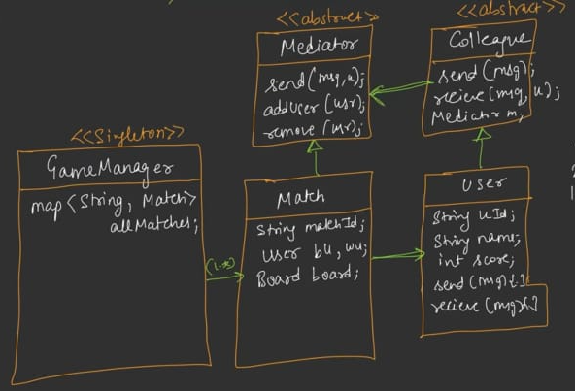

makeMove — Full Flow
- Validations:
  - If status != IN_PROGRESS → print "Game not in progress", return false
  - If getPlayerColor(player) != currentTurn → print "Not your turn", return false
  - piece = board->getPiece(from) → if null OR piece->color != playerColor → print "Invalid piece selection", return false
- Create Move object: Move(from, to, piece, board->getPiece(to))
- Validate via rules->isValidMove(move, board) → if false → print "Invalid move", return false
- Execute: board->movePiece(from, to) (handles capture removal, updates piecePositions map, marks piece hasMoved = true)
- Push to moveHistory; print "X moved piece from A to B"; board->display()
- Terminal checks (on opponent):
  - opponentColor = getOpponentColor(playerColor)
  - If rules->isCheckmate(opponentColor, board) → endGame(player, CHECKMATE) → return true
  - Else if rules->isStalemate(opponentColor, board) → endGame(player, STALEMATE) → return true
- Switch currentTurn = opponentColor
- Optionally print "Opponent is in check" if rules->isInCheck(opponentColor, board)
- Return true
Complexity: All loops bounded by 16 pieces → effectively O(1) constant time

3. Board
Dumb object — knows nothing about chess rules. Single Responsibility: manage pieces and their positions.

Fields
Field | Type | Purpose
grid | Piece* board[8][8] | 2D array (nullable cells)
piecePositions | map<Position, Piece*> | Position → Piece for O(1) lookup
Why 8×8 fixed: Chess rules are standardized for 8×8; scalability to 16×16 etc. is possible but adds no practical value.

Constructor
Calls initializeBoard() — places all 32 pieces at standard starting positions:
- Black back rank on row 0: Rook, Knight, Bishop, Queen, King, Bishop, Knight, Rook
- Black pawns on row 1
- White pawns on row 6
- White back rank on row 7

Methods
Method | Behavior
initialize() | Set starting positions (called from constructor)
placePiece(piece, position) | Set grid[pos.row][pos.col] = piece; also piecePositions[pos] = piece
removePiece(position) | grid[r][c] = nullptr; piecePositions.erase(pos)
getPiece(position) | Return grid[pos.row][pos.col]
isOccupied(position) | getPiece(pos) != nullptr
isOccupiedBySameColor(position, color) | Returns true if a piece exists and its color == given color
movePiece(from, to) | Remove captured piece if present (getPiece(to) and removePiece(to)); grid[from] = nullptr; grid[to] = piece; update piecePositions (erase from, insert to); piece->setHasMoved(true)
findKing(color) | Loop piecePositions; return position where piece->getType() == KING && piece->getColor() == color; else return invalid Position(-1,-1)
getPiecesOfColor(color) | Loop piecePositions; return vector of positions of pieces matching color
display() | Print full board with symbol notation
display() details: Prints borders + each cell symbol. Uses Piece::toString() — e.g., BR (Black Rook), WN (White Knight), BQ (Black Queen), etc. Uses color letter W/B + piece symbol K/Q/R/B/N/P.

6. Piece (Abstract)

Fields
Field | Type | Purpose
color | Color | WHITE or BLACK
pieceType | PieceType | Which piece type
hasMoved | bool | Has this piece moved at all (for pawn's 2-step rule)

Abstract Methods
Method | Signature | Purpose
getPossibleMoves(currentPos, board) | vector<Position> | All cells this piece can legally move to
getSymbol() | char | Single-char symbol (K/Q/R/B/N/P)

Concrete Method
Method | Purpose
toString() | Color letter + symbol (e.g., BR, WN)

7. Concrete Pieces — Move Logic

King
- 8 directions, 1 step each: directions = [(-1,-1), (-1,0), (-1,1), (0,-1), (0,1), (1,-1), (1,0), (1,1)]
- Single loop; new position = current + direction; must be isValid() and NOT isOccupiedBySameColor
- Symbol: K

Queen
- 8 directions, up to end of board in each
- Directions same as King; but for each direction, iterate i = 1..8 multiplying direction by i
- Break early when:
  - Position invalid → break that direction
  - Occupied by same color → break
  - (Also break after a capture — beyond a capture, cannot continue)
- Symbol: Q

Rook
- 4 directions (straight): [(-1,0), (0,-1), (0,1), (1,0)]
- Up to end (like Queen but only 4 directions)
- Same break rules as Queen
- Symbol: R

Bishop
- 4 diagonal directions: [(-1,-1), (-1,1), (1,-1), (1,1)]
- Up to end in each
- Symbol: B

Knight
- 8 fixed L-shapes: [(-2,-1), (-2,1), (-1,-2), (-1,2), (1,-2), (1,2), (2,-1), (2,1)]
- Single loop — each direction is a direct move (no "up to end")
- For each: new position; must be valid AND not isOccupiedBySameColor
- Symbol: N

Pawn
Special-case logic:
- Direction: +1 if WHITE (moving down in grid terms), -1 if BLACK
- Forward 1 step: new row = currentRow + direction; same col; if valid and unoccupied → add to moves
- Forward 2 steps on first move: if !hasMoved and both intermediate and 2-step cell are valid and unoccupied → add
- Diagonal captures: two diagonal-forward positions; only add if opponent piece exists there
- Symbol: P

8. PieceFactory (Factory Pattern)
Method | Signature
createPiece(type, color) | Piece* createPiece(PieceType, Color)
Logic: switch(type) → new King(color), new Queen(color), etc.
Why Factory: 6 piece classes, many construction points; centralizing construction simplifies board initialization and future extension.
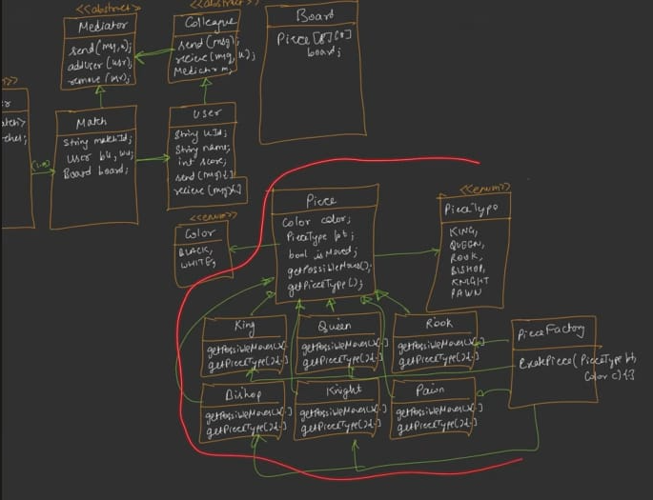

4. Position

Fields
Field | Type | Purpose
row | int | 0–7
col | int | 0–7

Methods
Method | Purpose
isValid() | row >= 0 && row < 8 && col >= 0 && col < 8
operator==(other) | Compare row AND col
operator<(other) | Comparator (row first, then col) — required for using Position as map key
toString() | "row, col" string
toChessNotation() | Convert to a1–h8 (columns → files a–h, rows → ranks 1–8)
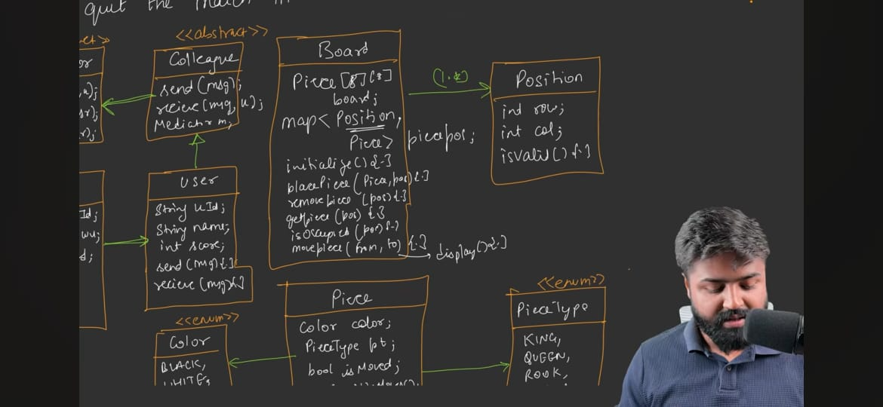

5. Move

Fields
Field | Type | Purpose
from | Position | Start position
to | Position | End position
piece | Piece* | Moving piece
capturedPiece | Piece* | Piece captured at target (may be null)
Getters/setters only.

9. ChessRules (Abstract Strategy)

Abstract Methods
Method | Signature | Purpose
isValidMove(move, board) | bool isValidMove(Move&, Board*) | Is this a legal move for this piece?
isInCheck(color, board) | bool isInCheck(Color, Board*) | Does this color's king have a check?
isCheckmate(color, board) | bool isCheckmate(Color, Board*) | Is this color checkmated?
isStalemate(color, board) | bool isStalemate(Color, Board*) | Is this color stalemated?
wouldMoveCauseCheck(color, move, board) | bool wouldMoveCauseCheck(Color, Move&, Board*) | If this color makes this move, will its king be checked?

10. StandardChessRules (Concrete)

isValidMove(move, board)
- piece = move.getPiece(); possibleMoves = piece->getPossibleMoves(move.getFrom(), board)
- Check if move.getTo() exists in possibleMoves → if not, return false
- return !wouldMoveCauseCheck(piece->getColor(), move, board) — a move that exposes own king to check is invalid

wouldMoveCauseCheck(color, move, board)
- movingPiece = board->getPiece(move.getFrom())
- capturedPiece = board->getPiece(move.getTo())
- If movingPiece is null → return true (invalid state)
- Temporarily execute:
  - board->removePiece(move.getFrom())
  - If capturedPiece exists → board->removePiece(move.getTo())
  - board->placePiece(movingPiece, move.getTo())
- result = isInCheck(color, board)
- Undo:
  - board->removePiece(move.getTo())
  - board->placePiece(movingPiece, move.getFrom())
  - If capturedPiece existed → board->placePiece(capturedPiece, move.getTo())
- Return result

isInCheck(color, board)
- kingPos = board->findKing(color); if kingPos.row == -1 → return false (no king found)
- opponentColor = getOpponentColor(color)
- opponentPieces = board->getPiecesOfColor(opponentColor)
- For each opponentPiecePos:
  - piece = board->getPiece(opponentPiecePos)
  - moves = piece->getPossibleMoves(opponentPiecePos, board)
  - For each target in moves: if target == kingPos → return true
- Return false

isCheckmate(color, board)
- If !isInCheck(color, board) → return false (checkmate requires check)
- ownPieces = board->getPiecesOfColor(color)
- For each ownPiecePos:
  - piece = board->getPiece(ownPiecePos)
  - moves = piece->getPossibleMoves(ownPiecePos, board)
  - For each target: build Move(ownPiecePos, target, piece, board->getPiece(target))
  - If isValidMove(move, board) → return false (an escape move exists)
- Return true — checkmate
Key insight: isValidMove internally invokes wouldMoveCauseCheck, so any move that fails to resolve check is already excluded.

isStalemate(color, board)
Only difference from checkmate is the first check:
- If isInCheck(color, board) → return false (stalemate = not in check, but no valid moves)
- Remaining logic identical to checkmate: loop all own pieces, all possible moves, and check isValidMove
- If a valid move exists → false; else true (stalemate)
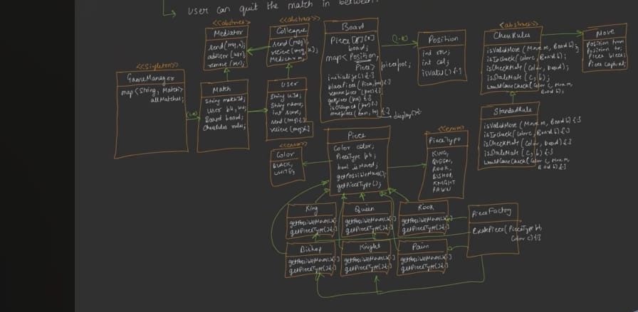

11. IMediator (Abstract — chat room interface)
Method | Purpose
registerColleague(Colleague*) | Register a user
send(message, fromUser) | Broadcast / forward message
sendPrivate(fromUser, toUser, message) | Direct message (general pattern; Match uses specific variant)
Note on Match's implementation: Chess uses only sendMessage(message, user) (recipient is always the opponent — only 2 players exist). The generic sendPrivate isn't needed. Match also skips addUser (only 2 allowed) and delegates removeUser → quitGame.

12. IColleague (Abstract — chat participant interface)
Field | Purpose
IMediator* mediator | Reference to mediator
Method | Purpose
send(message) | Forward to mediator's send
receive(message) | Handle incoming message
setMediator(IMediator*) | Set reference
getMediator() | Getter

13. User (Concrete Colleague)

Fields
Field | Type | Purpose
userId | string | Unique ID
name | string | Display name
score | int | Starting score 1000

Methods
Method | Purpose
Constructor | Takes userId, name (score defaults to 1000)
getUserId, getName, getScore | Getters
incrementScore(delta), decrementScore(delta) | Modify score
send(message) | mediator->send(message, this)
receive(message) | Prints "<name> received: <message>" (console; in real app, would show in UI)
toString() | Name + score

14. Message
Field | Type |  | Purpose
senderId | string |  | Who sent
content | string |  | Message body
timestamp | string (or time_t) |  | When sent
Method |  | Purpose
toString() |  | Format: [senderId]: content

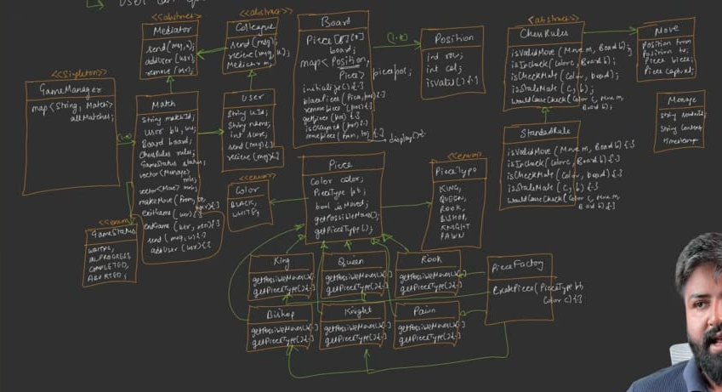

15. MatchingStrategy (Abstract Strategy)
Method | Signature
findMatch(User, vector<User>& waitingUsers) | User* findMatch(User, vector<User>&)
Returns: a User* opponent (or null if none matched)

16. ScoreBasedMatchingStrategy (Concrete)

Fields
Field | Type | Purpose
scoreTolerance | int | Max acceptable score difference (e.g., 100)

findMatch(user, waitingUsers) Logic
- bestMatch = nullptr, bestScoreDiff = INT_MAX
- For each waitingUser:
  - Skip if waitingUser.userId == user.userId (don't match self)
  - scoreDiff = abs(waitingUser.score - user.score)
  - If scoreDiff < scoreTolerance AND scoreDiff < bestScoreDiff:
    - bestMatch = &waitingUser
    - bestScoreDiff = scoreDiff
- Return bestMatch
Purpose: A beginner (1000) won't match a 3000-level pro — tolerance excludes them.

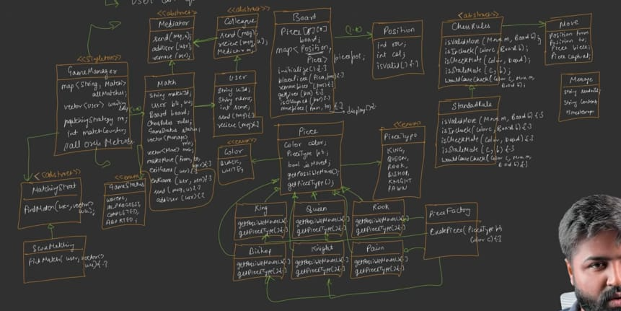

17. ChessSystemDemo (Utility — not in UML)
Purpose: Simulates the Scholar's Mate (4-move checkmate) so the tutorial can demonstrate a full game end-to-end.
Setup:
- Users: Aditya (white), Rohit (black)
- Match created directly with new Match("demo_match", aditya, rohit)
Scholar's Mate moves:
Move # | White (Aditya) | Black (Rohit)
1 | Pawn E2 → E4 | Pawn E7 → E5
2 | Bishop F1 → C4 | Knight B8 → C6
3 | Queen D1 → H5 | Knight G8 → F6
4 | Queen H5 → F7 (captures pawn) | — (Checkmate)
After checkmate: Two chat messages exchanged:
- Aditya: "Good game"
- Rohit: "Thanks, that was a quick one"

UML Relationships Summary
Relationship | Details
GameManager → Match | 1..many (activeMatches map) — Composition for MatchingStrategy (Manager owns it)
GameManager → User (waitingLobby) | 1..many (list)
GameManager → MatchingStrategy | Composition (diamond) — Strategy doesn't exist independently
Match → Board | Composition
Match → ChessRules | Composition
Match → User | Exactly 2 (white + black)
Match → Move (history) | 1..many
Match → Message (chat history) | 1..many
Match is-a IMediator | Implements
User is-a IColleague | Implements
Board → Piece | 1..many (2D grid)
Board → Position→Piece map | 1..many
Piece ← King/Queen/Rook/Bishop/Knight/Pawn | Inheritance
ChessRules ← StandardChessRules | Inheritance
MatchingStrategy ← ScoreBasedMatchingStrategy | Inheritance
PieceFactory creates Piece | Factory
Composition chosen for GameManager → MatchingStrategy (strategy is bound to manager; can't exist standalone).

Design Patterns Used
Pattern | Where | Purpose
Singleton | GameManager | Single platform orchestrator
Facade | GameManager | One entry point to the whole ecosystem
Strategy | ChessRules; MatchingStrategy | Interchangeable rules and matchmaking
Factory | PieceFactory | Creates 6 piece types centrally
Mediator | Match ↔ User (IMediator/IColleague) | In-app chat without user-to-user references
Composition | Multiple (GameManager→MatchingStrategy, Match→Board, Match→ChessRules, Board→Piece) | Strong ownership
Template Method | initializeBoard/display loop patterns | Fixed skeleton, variable details
Deliberate OCP trade-off: Rules are hardcoded as new StandardChessRules() in Match constructor (single rule type for now); but the abstraction allows extension without code changes elsewhere. Similarly GameManager hardcodes new ScoreBasedMatchingStrategy(100) — can be moved to constructor param later.
Deliberate SRP trade-off: GameManager directly calls match.getBoard()->display() — Law of Demeter violation; acceptable for the demo; could be refactored as match.displayBoard().
Clean UML:-
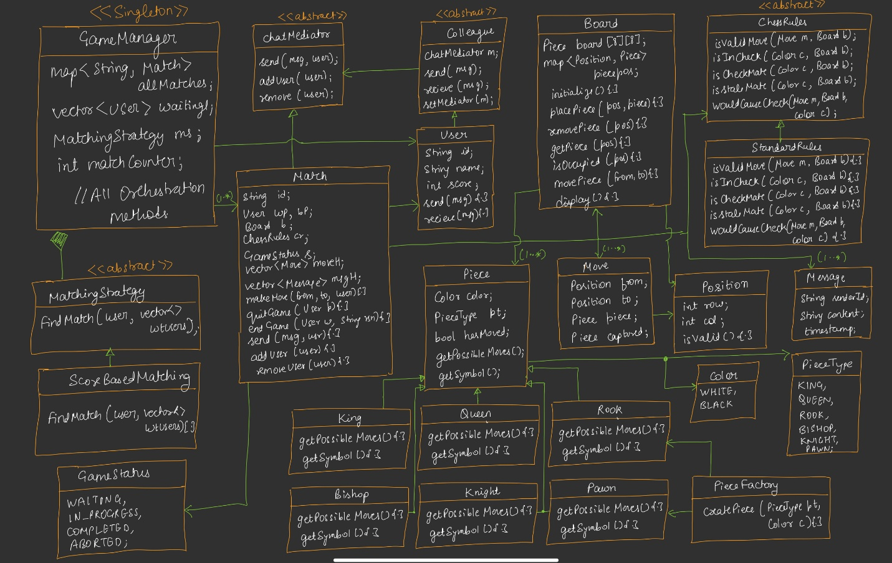
Code…see Notes

Complete Gameplay Flow
text
User → GameManager.getInstance().requestMatch(user)
│
├─ matchingStrategy->findMatch(user, waitingLobby)
│
├─ If opponent found:
│ ├─ Erase opponent from waitingLobby
│ ├─ matchId = "match_" + (++matchCounter)
│ ├─ new Match(matchId, currentUser, opponent)
│ ├─ activeMatches[matchId] = match
│ └─ match.getBoard()->display()
│
└─ Else:
└─ waitingLobby.push_back(user)

GameManager.makeMove(matchId, from, to, player)
│
└─ match.makeMove(from, to, player)
│
├─ Validations (status, turn, piece, color)
├─ new Move(from, to, piece, captured)
├─ rules->isValidMove(move, board) → false? return
├─ board->movePiece(from, to)
├─ moveHistory.push(move); print; board->display()
├─ opponent = getOpponentColor(playerColor)
├─ rules->isCheckmate(opponent, board)? → endGame
├─ rules->isStalemate(opponent, board)? → endGame
└─ currentTurn = opponent

GameManager.quitMatch(matchId, player)
│
└─ match.quitGame(player)
├─ opponent wins
├─ endGame(opponent, QUIT)
└─ player score -= 50 (per spec; code demo uses 30/20)

GameManager.sendChatMessage(matchId, text, user)
│
├─ msg = new Message(user.id, text, now)
└─ match.sendMessage(msg, user)
├─ chatHistory.push(msg)
├─ recipient = (user == whitePlayer ? blackPlayer : whitePlayer)
└─ recipient->receive(msg)

Demo Output Walkthrough

Demo 1: Scholar's Mate
Output sequence:
- Board printed with all pieces placed (BR, BN, BB, BQ, BK, BB, BN, BR on row 0; BP×8 on row 1; WP×8 on row 6; WR, WN, WB, WQ, WK, WB, WN, WR on row 7)
- Move log:
  - "Aditya moved Pawn from e2 to e4"
  - "Rohit moved Pawn from e7 to e5"
  - "Aditya moved Bishop from f1 to c4"
  - "Rohit moved Knight from b8 to c6"
  - "Aditya moved Queen from d1 to h5"
  - "Rohit moved Knight from g8 to f6"
  - "Aditya moved Queen from h5 to f7"
- "Game Over! Aditya wins by CHECKMATE"
- Score updates printed: Aditya +30 → 1030, Rohit −20 → 980 (implementation)
- Chat messages:
  - "Aditya: Good game"
  - "Rohit: Thanks, that was a quick one"

Demo 2: Matchmaking
Setup: 3 users (Saurabh, Manish, Abhishek) all score 1000; requestMatch called sequentially.
Output sequence:
- "Saurabh is looking for a match" → goes to waiting lobby ("Saurabh added to waiting list")
- "Manish is looking for a match" → matches Saurabh (both 1000):
  - "Match started between Manish (white) and Saurabh (black)"
  - "Match found"; board printed
- "Abhishek is looking for a match" → no match (only these 2 in lobby) → "Abhishek added to waiting list"
- displayActiveMatches():
  - "Active matches: 1 (Manish vs Saurabh)"
  - "Waiting users: 1 (Abhishek)"

Board Display Format
Each cell prints a 2-character code:
- First character: W (white) or B (black)
- Second character: K/Q/R/B/N/P
Examples:
- BR = Black Rook
- WN = White Knight
- BK = Black King
- WQ = White Queen
- Empty cells: -- (or similar)
Why not proper Unicode chess pieces? Console environment; the tutorial mentions it would look better with a front end; Piece::toString() provides the code format.

Real-World Extensions / Notes Discussed
- Front-end: The project currently has no UI; adding a front end would make it a complete deployable project.
- Undo feature: moveHistory is stored exactly for this; a future undoMove() can reverse moves from history.
- Custom rules: Extend ChessRules for variants (e.g., no-castling chess); Match would accept the rule as constructor parameter instead of hardcoding.
- Smarter Matching: Beyond score, could use ping/latency, geographic proximity, or ELO-based pairing.
- Optimization: The tutorial notes the current logic does "brute-force" checks (loops over all pieces every time); with only 16 pieces max per side, complexity is effectively O(1) and fine. For larger boards or variants, caching/memoization would help.
- Quit penalty: The tutorial's implementation and the stated requirements differ slightly on exact point values (50 vs 30); the underlying principle (penalty + bonus) is what matters.

Key Takeaways
- Top-down design for board games — start with GameManager (top-level) and decompose
- Two-tier separation: GameManager (orchestrator) + Match (self-contained game room) — clean boundary
- Board is a dumb object — knows no chess rules (SRP); all logic lives in ChessRules
- Mediator pattern enables chat without players knowing each other's references (relates to earlier Mediator LLD notes)
- Map<matchId, Match> enables concurrent matches — single manager handles all
- Strategy abstraction for both rules and matching → extensible without touching callers
- Factory for pieces — 6 concrete types behind one creation method
- hasMoved flag supports pawn's 2-step rule and would support castling/en-passant in future
- wouldMoveCauseCheck — temporary execute + undo is the cleanest way to validate self-check
- isCheckmate vs isStalemate — differ only by the initial check-status condition
- Constants: 8×8 board, 16 pieces/side, 2 players — all naturally bounded → O(1) complexity per operation
- toString() with W/B + K/Q/R/B/N/P notation is sufficient for console; front-end would use Unicode/imagery

One-Line Summary
GameManager (Singleton + Facade) orchestrates multiple concurrent Matches (each a Mediator for in-app chat), each Match coordinates a Board (dumb piece holder with 8×8 grid + position map) and a ChessRules (Strategy with isValidMove, isInCheck, isCheckmate, isStalemate, wouldMoveCauseCheck), while a ScoreBasedMatchingStrategy (Strategy) pairs players with closest score from the waiting lobby — all standard chess rules implemented, scored matchmaking, quit/checkmate/stalemate endings, and history-storage ready for undo.

